Unit 16. Security
What This Unit Is About
This unit introduces the concepts of AIX users and groups, and also the files that
contain user account information.
What You Should Be Able To Do
After completing this unit, students should be able to:
- Define the concepts of users and groups, and define how and when these should be allocated on the system
- Define ways of controlling root access on the system
- Define the uses of SUID, SGID and SVTX permission bits
- Identify the data files associated with users
How You Will Check Your Progress
Accountability:
- Checkpoint questions
- Exercises
References:
- Elements of Security: AIX 4.1 GG24-4433

16.1 Objectives
After completing this unit, students should be able to:
- Define the concepts of users and groups, and define how and when these should be allocated on the system
- Define ways of controlling root access on the system
- Define the uses of SUID, SGID and SVTX permission bits
- Identify the data files associated with users
Notes:

16.2 Security Concepts

16.2.1 User Accounts
- Each user has a unique name, ID and password
- File ownership is determined by user ID
- The owner is usually the user who created the file, but ownership can be transferred by root
- Default users:
- root super user
- adm, sys, bin… IDs that own system files but cannot be
used for login

16.2.2 Groups
- Users who need to access the same files can be placed in a single group
- Group ID gives extra level of file ownership
- Default groups:
- System administrators
- Staff ordinary users
Notes:
- The security of the system is based on a user being assigned a unique name, user ID (UID) and password. When the user logs in, the UID is used to validate all requests for file access.
- When a file is created, the UID associated with the process that created the file is assigned to the file. Only the owner or root can change the access permissions.
- Users that require shared access to a set of files are placed in groups. A user can belong to multiple groups. Each group has a unique name and Group ID (GID). The GID is also assigned to a file when it is created.
- By default there are two groups on the system for users:
- system - for administrators
- staff - for all normal users
- Other groups exist for access to certain system functions or to own certain system files, and extra groups can be added by both root and ordinary users.

16.3 Groups
- A group is a set of users, all of whom need access to a given set of files
- Every user is a member of at least one group and can be a member of several groups
- The user has access to files in all of the groups in its groupset. To list the groupset use the groups or setgroups command
- The user's primary group is used for file ownership on creation. To change the primary group use the newgrp or setgroups command
Notes:
- The creation of groups to organize and differentiate the users of a system or network is part of systems administration. The guidelines for forming groups should be part of the security policy. Defining groups for large systems can be quite complex and once a system is operational, it is very difficult to change the group structure. Investing time and effort in devising group definitions before your system arrives is recommended.
- Groups should be defined as broadly as possible and consistent with your security policy. Do not define too many groups because defining groups for every possible combination of data type and user type can lead to impossible extremes.
- A group administrator is a user who is allowed to assign the members and administrators of group. It does not imply that the user has any “administrative” abilities for the system.
- There are three types of groups on the system:
- User Groups
- User groups should be made for people who need to share files on the system, such as people who work in the same department, or people who are working on the same project.
- System Administrator Groups
- System administrators are automatically members of the group system. Membership of this group allows the administrators to perform some of the system tasks without having to be the root user.
- System Defined Groups
- Several system-definer groups exist. staff is the default group for all non-administrative users created in the system, security is another system defined group having limited privileges for performing security administration. The system-defined groups are used to control certain subsystems.

16.4 Group Hierarchy
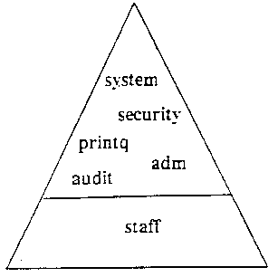

- Any user who belongs to the system, security, printq, …groups can perform certain administrative functions
Notes:
- Group destinations often follow user job functions instead of organizational lines.
- Common groups on the system are:
- system For most configuration and standard hardware and software maintenance
- printq For managing queuing. Typical commands which can be run by
members of this group are: enable, disable, qadm, qpri, etc.
- security To handle most passwords and limits control. Typical commands which
can be run by members of this group are: mkuser, rmuser, pwdadm,
chuser, chgroup, etc.
- adm Most monitoring functions such as performance, cron, accounting
- staff Default group assigned to all new users. You may want to change this in
/usr/lib/security/mkuser.defaults
- audit For auditors

16.5 User Hierarchy
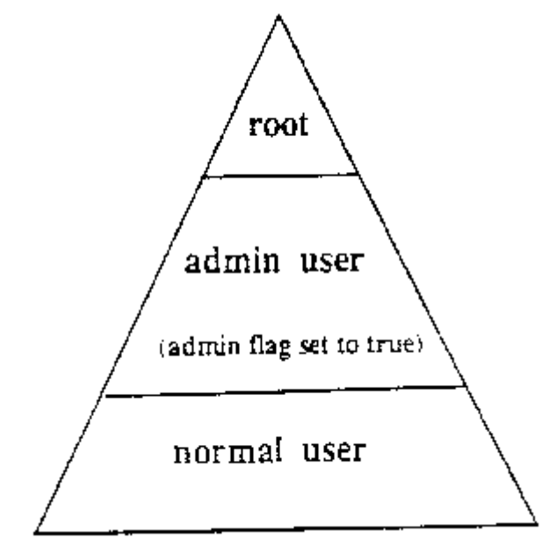

- To protect important users/groups from members of the security group AIX has admin users and admin groups
- Only root can add/remove/change an admin user or admin group
- Any user on the system can be defined as an admin user regardless of the group they are in
# cat /etc/security/user
user1:
admin = true
Notes:
- The ability to perform certain system tasks (like creating users) depends upon the standard AIX file permissions. Most system admin tasks can be performed by users other than root by assigning those users to groups such as system, security, printq, cron, adm, audit. In particular, a user in the security group can add/remove/change other users and groups.
- To protect important users/groups from users in the security group, AIX has a mechanism for implementing a third level of user hierarchy: root, admin users/groups and normal users/groups. Only root can add/remove/change an admin user or admin group. Therefore, you can define a user with a high level of access, but who is protected from users in the security group.

16.6 Control root's Access
- Restrict access to privileged logins
- root's password should be changed on an unannounced schedule by the system administrator
- Assign different root passwords to different machines
- System administrators should always login as themselves first and then su to root instead of logging in as root. This helps provide an audit trail for root usage
- The PATH used by root must not be compromised
Notes:
- If the root password is known by too many people, no one can be held accountable. The root password should be limited to a single system administrator. The fewer people know root's password the better.
- The system administrator should ensure that distinct root passwords are assigned to different machines. You may allow normal users to have the same passwords on different machines, but never do this for root.
- Attempts to become root through su can be investigated. Successful and unsuccessful attempts might be logged by the audit system.
- root's PATH is used by many implicit system functions, not just by a user logged in as root.

16.7 Su
- The su command can be used to switch user to either root or the user specified. A new session is also created
For example:
# su team01
$ whoami
team01
- If the command is specified with the -, then the environment is changed to that of the user specified (or if no user is specified, then root is used)
$ su - root
# pwd
/
Notes:
- The su command runs in a subshell with the effective user ID and root privileges (if no username is specified). You will be asked for root's password. To end the session. type in exit or <ctrl-d> and this will return you to the original shell session and privileges.
- For example, su - jim will setup the environment as if you had logged in as jim. This will start a subshell using jim's login environment.

16.8 Security Logs

16.8.1 /var/adm/sulog
Each time the su command is executed, an entry is made in the sulog file. Use
pg, more, or cat to view.

16.8.2 /var/adm/wtmp and /etc/utmp
When a user logs in successfully, the login program writes in the above two files.
Use who command to view.

16.8.3 /etc/security/failedlogin
On an invalid login attempt, due to an incorrect login name or password, the login
program makes an entry in the failedlogin file. Unrecognizable login names will
be logged as UNKNOWN. Use who command to view.
Notes:
- The sulog file is an ASCII text file that can be viewed with more or pg. In the file the following information is recorded: date, time, system name and login name. The file also records whether or not the login attempt was successful (and indicates a success by a + and a failed login by a -)
- The /etc/utmp file contains a record of users logged into the system, and the /var/adm/wtmp file contains connect-time accounting records. To obtain information from either file use the who command with the file name. The who command normally examines the /etc/utmp but you can specify either one of the named files as arguments to the command.
- The last command can also be used to display in reverse chronological order, all previous logins and logoffs still recorded in the /var/adm/wtmp file. The /var/adm/wtmp file collects login and logout records as these events occur and holds them until the records are processed by the accounting commands.
- For example:
- last root displays all the recorded logins and logoffs by the user root
- last reboot displays the time between reboots of the system

16.9 File/Directory Permissions
Perm.
Bit
File

r
User can read the contents of file
w
User can change the contents of file
x
User can user the file name as a command
SUID
Program runs with ef-fective UID of owner
SGID
SVTX
Program runs with ef-fective GID of owner
―
Directory
user can list the contents of directory

user can create and remove file within directory
within directory
User can cd to directory and can use it in PATH
―
files created in directory inherit the same group as the directory *
to delete a file in directory, the user must own the file or the directory
Notes:
- There are a number of permission bits associated with files and directories. The standard r (read), w (write) and x (execute) permissions define three levels of access for the “user” (owner), "group" and "others". In addition there are three permission bits known as SUID (set UID). SGID (set GID) and SVTX (sticky bit).
- SUID on an executable file means that when the file runs, the process runs with an effective UID of the owner of the file. SUID is not supported on shell scripts.
- SUID has no meaning on a directory.
- SGID on an executable file means that when the file runs, the process runs with an effective GID of the group owner of the file.
- SGID on a directory means that any file/directory created within the directory will have the same group ownership as the directory rather than the primary group of the user.
- SVTX on a file has no meaning in AIX (It was used in earlier versions of UNIX)
- SVTX on a directory means that even if the directory has global write permission (for example. /tmp), users cannot delete a file within unless they either own the file or the directory.
- Traditional UNIX used SVTX to keep a program in memory after it had completed running, but with memory management routines, this is no longer necessary. SVTX is known as the sticky bit.
- The SGID permission bits are propagated down through the directory structure, so that any directory created in a directory with the SGID bit set also inherits that bit.

16.10 Reading Permissions
- Interpreting fields reported by an ls command:

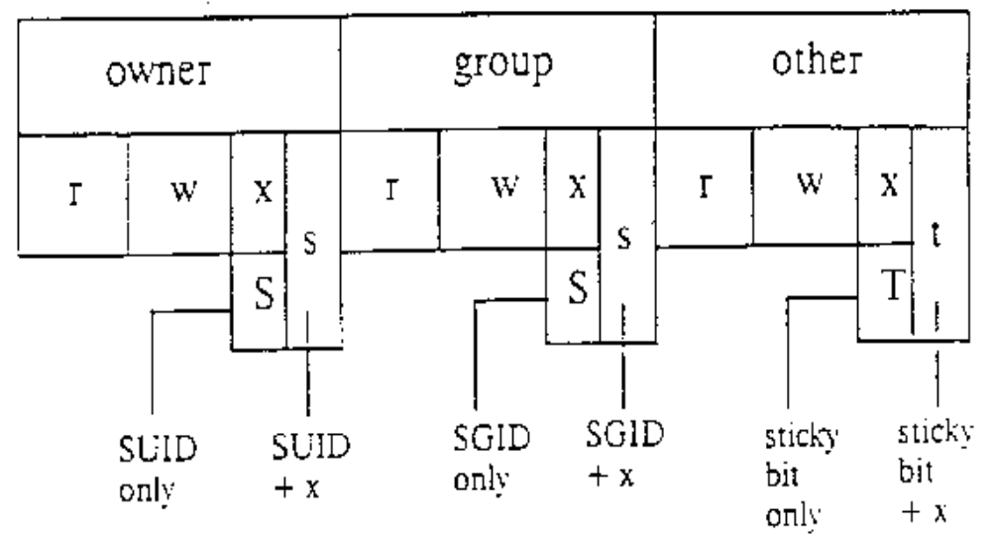# ls -ld /bin/passwd /tmp
-r-sr-xr-x root security ... /bin/passwd
drwxrwxrwt bin bin ... /tmp
- When a user runs passwd their effective id changes to root
Notes:

16.11 Changing Permissions & Ownership

16.11 1 Changing permissions on a file/directory:
- # chmod +t dir1 or # chmod 1770 dir1 (SVTX)
- # chmod g+s dir2 or # chmod 2750 dir2 (SGID)
- # chmod u+s cmd or # chmod 4750 cmd (SUID)
- # ls -ld dir1 dir2
- drwxrwx─t … dir1
- drwxr―s─ … dir2
- -rwsr―x─ … cmd

16.11.2 Changing ownership of a file/directory:
- # chown fred file1
- # chgrp staff file l
Notes:
- File permissions are changed using the chmod command. There are special flags which can be used to change the SUID/SGID/SVTX bits.
- chmod {[ugo]+[rwx] ︱[ug]+s ︱+t} file
- The octal form of the chmod command can also be used.
- The owner of a file can be changed using the chown command. Only root can run the chown command.
- chown user[:group] file ...
- The group ownership of a file can be changed using the chgrp command. The owner or root can change the group ownership of a file. (The owner can only change the group to another group in his group set.)
- chgrp group file…
- To change ownership and group with one command use the format:
- Chown find:budget file 1

16.12 Umask
- The umask governs permissions on new files and directories
- /etc/security/user specifies default and individual user umasks
- System default umask is 022. A umask of 027 is recommended
- If the umask value is set to 022, then any ordinary files or directories created will inherit the following permissions:
Ordinary file: r w - r - - r - -
Directory: r w x r - x r - x
Notes:
- The umask specifies what permission bits will be set on a new file when it is created.
- It is an octal number that specifies which of the permission bits will not be set. On a file, the execute permissions are never set.
- For example, A umask of 022 specifies that the permissions on a new file will be 644 or on a new directory will be 755. A umask of 000 would give 666 permissions on a file (i.e. read/write access to all) or 777 on a directory.
- The default setting of the umask is 022. For tighter security you should make the umask 027 or even 077.
- To view/change the value of the umask for the current session use the umask command.
- The umask is specified in /etc/security/user. The "default" stanza in this file specifies the system wide default, but a value can be specified on a per-user basis.

16.13 Security Files
- Files used to contain user attributes and control access:
- /etc/passwd valid users (not passwords)
- /etc/group valid groups
- /etc/security directory not accessible to normal users
- /etc/security/passwd user passwords
- /etc/security/user user attributes, password restriction
- /etc/security/limits user limits
- /etc/security/environ user environment settings
- /etc/security/login.cfg login settings
- /etc/security/group group attributes
Notes:
- The security on the system is controlled by a number of ASCII files.
- The /etc/passwd file lists the valid users, their userID, primary group, home directory and default login shell.
- The /etc/group file lists the valid groups, their groupID and members.
- The above files have global read access to all users. A number of other files control the attributes of users. They are in the /etc/security directory which can only be accessed by root or the security group
- /etc/security/passwd contains the encrypted password and update information for users.
- /etc/security/user contains extended user attributes.
- /etc/security/limits contains process resource limits for users.
- /etc/security/environ contains environment variables for users. This file is not often used.
- /etc/security/login.cfg is a configuration file for the login program. This contains security enhancements that limit the logins on a port. For example, the number of login attempts and lists the valid login programs (shells).
- /etc/security/group contains extended group attributes.

16.14 /etc/passwd File
# cat /etc/passwd
root:!:0:0::/:/bin/ksh
daemon:!:1:1::/etc:
bin:!:2:2::/bin:
sys:!:3:3::/usr/sys:
adm:!:4:4::/var/adm:
uucp:!:5:5::/usr/lib/uucp:
guest:!:100:100::/home/guest:
nobody:!:4294967294:4294967294::/:
lpd:!:104:9::/:
john:!:200:0:×7560 5th floor:/home/john:/bin/ksh
dougal:*:201:9::/home/dougal:/bin/ksh

Notes:
- The /etc/passwd file lists the users on the system and some of their attributes. This file must be readable by all users, because commands such as is access it.
- The fields in the /etc/passwd file are:
- user name - up to 8 alphanumeric characters (not all upper case)
- password - on older UNIX systems this contained the encrypted password. This will still work, but on AIX Version 4 this should only contain a ! to refer to the /etc/security/passwd file. Other common values are a * which means the id is invalid and no value means there is no password assigned. Use the pwdck command to correctly transfer information from this field to the /etc/security/passwd file
- uid - the user id number for the user
- gid - the id of the primary group to which this user belongs
- fullname - any descriptive text for the user
- directory - the login directory of the user and the Initial value of the SHOME variable
- login program - the login shell of the user and the initial value of the SSHELL variable

16.15 /etc/security/passwd File
# cat /etc/security/passwd

root:
password = 92t .mzJBjlfbY
lastupdate = 668124164
flags =
daemon:
password = *
bin:
password = *
:
john:
password = q/gD6q.ss21x.
lastupdate = 666293529
flags = ADMCHG,ADMIN,NOCHECK

Notes:
- The /etc/security/passwd file can only be accessed by root. The login, passwd, pwdadm and pwdck commands (which run with root authority) update this file. The information in this file is the password and its associated information. It is in stanza format with a stanza for each user. The valid entries are:
- Password Either the encrypted password or * for invalid or blank for no
password
- lastupdate The date and time of the last password update in seconds from
January 1 1970
- flags ADMCHG - the password was last changed by an dministrator
or root
ADMIN - the user's password can only be changed by root
NOCHECK - password restrictions are not in force for this
user.
(see /etc/security/user for password restrictions)

16.16 /etc/security/user File
# cat /etc /security/user
default:
admin = false
login = true
su = true
daemon = true
rlogin = true
sugroups = ALL
admgroups =
ttys = ALL
auth1 = SYSTEM
auth2 = NONE
tpath = nosak
umask = 022
expires = 0
.
.
.
Notes:
- admin
- Defines the administrative status of the user. Possible value: true or false.
- login
- Defines whether a user can login. Possible values: true or false.
- su
- Defines whether other users can switch to this user account. The su command supports this attribute. Possible values: true or false.
- daemon
- Defines whether the user can execute programs using the cron daemon or the system resource controller (SRC). Possible values: true or false.
- rlogin
- Defines whether the user account can be accessed by remote logins. Command rlogin and telnet support this attribute. Possible values: true or false.
- sugroups
- Defines which groups can switch to this user account. Alternatively you may explicitly deny groups by preceding the group name with a ! character. Possible values: A list of valid groups separated by commas, ALL or *
- admgroups
- Lists the groups that a user administers. The value is a comma - separated list of valid group names.
- ttys
- Defines which terminals can access the user account. Alternatively you may explicitly, deny terminals by preceding the terminal name with the! character. Possible values: List of device paths separates by commas, ALL or *
- auth1
- Defines the primary authentication method for a user, which by default is set to the password program. The commands login, telnet, rlogin and su support these authentication methods.
- auth2
- Defines the secondary authentication methods for a user. It is not a requirement to pass this method to login.
- tpath
- Defines the user’s trusted path characteristics. Possible values: nosak, notsh, always or on. (For more info either refer to info or to the IX41 course).
- umask
- Defines the default umask for the user. Possible valuesL 3-digit octal value.
- NB.Boolean values(i.e.true or false) may use any of the following values.These values are not case sensitive: true, false, yes, no, always, never.
- expires
- Defines the expiration time for the user account. Possible values: a valid date in the form MMDDHHMMYY or 0. If 0, the account does not expire. If 0101000070 then account is disabled.

16.17 /etc/security/user File Continued
Default:
SYSTEM = "compat"
logintimes =
pwdwarntime = 0
account_locked = false
loginretries = 0
histexpire = 0
histsize = 0
minage = 0
maxage = 0
maxexpired = -1
minalpha = 0
minother = 0
minlen = 0
mindiff = 0
maxrepeats = 8
pwdchecks =
Notes:
- SYSTEM
- Describes Version 4 authentication requirements. This attribute can be used to describe multiple or alternate authentication methods the user must use successfully before gaining access to the system. Possible tokens are:
- Files which will allow only local users access to the system
- compat which is the normal login procedure and therefore will allow
local and NIS users access to the system
- DCE which is the Distributed Computing Environment authentication
- logintimes
- Defines the times a user can login. The value is a comma separated list of items as follows:
- [!][MMdd[-MMdd]]:hhmm-hhmm
or
- [!]MMdd[-MMdd][:hhmm-hhmm]
or
- [!][w[-w]]:hhmm-hhmm
or
- [!]w[-w][:hhmm-hhmm]
- where MM is a month number (00=January, 11 -December), dd is the day on the month, hh is the hour of the day (00 - 23), mm is the minute of the hour, and w is a weekday (0=Sunday, 6=Saturday).
- pwdwarntime
- The number of days before a forced password change that a warning will be given to the user informing then of the impending password change. Possible values: a positive integer or 0 to disable this feature.
- account_locked
- Defines whether the account is locked. Locked accounts cannot be used for login. Possible values: true or false.
- logintries
- The number of invalid login attempts before a user is not allowed to login. Possible values: a positive integer or 0 to disable this feature.
- histexpire
- Defines the period of time in weeks that a user will not be able to reuse a password. Possible values: an integer value between 0 and 260. 26 (approximately 6 months) is the recommended value.
- histsize
- Defines the number of previous passwords which cannot be reused. Possible values: an integer between 0 and 50.
- minage
- Defines the minimum number of weeks between password changes. Default is 0.
- Range: 0 to 52.
- maxage
- Defines the maximum number of weeks a password is valid. The default is 0, which is equivalent to unlimited. Range: 0 to 52.
- maxexpired
- Defines the maximum number of weeks after maxage that an expired password can be changed by a user. The default is –1, which is equivalent to unlimited. Range: -1 to 52, maxage must be greater than 0 for maxexpired to be enforced, (root is exempt from maxexpired).
- minalpha
- Defines the minimum number of alphabetic characters in a password. The default is 0. Range: 0 to 8.
- minother
- Defines the minimum number of non-alphabetic characters in a password. The default is 0. Range: 0 to 8.
- minlen
- Defines the minimum length of a password. The default is 0. Range: 0 to 8.
- Note that the minimum length of a password is determined minlen and/or "minalpha + minother", whichever is greater, “minalpha + minother” should never be greater than 8.
- If "minalpha + minother" is greater than 8, then minother is reduced to "8 - minalpha".
- mindiff
- Defines the mini-mum number of characters in the new password that were not in the old password. The default is 0. Range: 0 to 8.
- maxrepeats
- Defines the maximum number of times a given character can appear in a password. The default is 8, which is equivalent to unlimited. Range: 0 to 8.
- dictionlist
- Defines the password dictionaries used when checking new passwords. The format is a comma separated list of absolute path names to dictionary files. A dictionary file contains one word per line where each word has no leading or trailing white space. Words should only contain 7 bit ASCII characters. All dictionary files and directories should be write protected from everyone except root. The default is valueless which is equivalent to no dictionary checking.
- pwdchecks
- Defines external password restriction methods used when checking new passwords. The format is a comma separated list of absolute path names to methods and/or method path names relative to /usr/lib. A password restriction method is a program module that is loaded by the password restrictions code at runtime. All password restriction methods and directories should be write protected from everyone except root. The default is valueless, which is equivalent to no external password restriction methods.

16.18 Group Files
# more /etc/group
system:!:0:root,john
staff:!:1:john
bin:!:2:root,bin
sys:!:3:root,bin,sys
adm:!:4:bin,adm
uucp:!:5:uucp
mail:!:6:
security:!:7:root
nobody:!:4294967294:nobody,lpd
usr:!:100:guest
accounts:!:200:john
# more /etc/security/group
Notes:
system:
admin = true
staff:
admin = false
:
accounts:
admin = false
adms = john
- The fields in the /etc/group file are:
- group - up to 8 alphanumeric characters (not all upper case)
- password - this field is not used in AIX Version 4 and should contain a !
- gid -the groupID
- members - a comma-separated list of the users who belong to this group
- The /etc/security/group file is a stanza file with one stanza for each group. The valid entries are:
- admin true or false, whether the group is an administrative group
- adms a comma separated list of the users who are administrators for the
group. If admin=true this stanza is ignored because only root can
change an administrative group.

16.19 /etc/security/login.cfg File

Notes:
default:
:
herald = "\n\n\n\n\n\n\n\n\n\n\n\n\n\n\n\n
\n\n\n\n This is the console. Restricted use only.
\nlogin:
logintimes =
logindisable = 0
logininterval = 0
loginreenable = 0
logindelay = 0
- herald
- Specifies the initial message to be printed out when getty or login prompts for a login name. This value is a string that is written out to the login port. If the herald is not specified, then the default herald is gotten from the message catalog associated with the language set in /etc/environment.
- logintimes
- Defines the times a user can use this port to login.
- logindisable
- Number of unsuccessful login attempts before this port is locked. Use this in conjunction with logininterval
- logininterval
- The number of seconds during which logindisable unsuccessful attempts must occur for a port to be locked.
- loginreenable
- The number of minutes after a port is locked that it will automatically unlocked.
- logindelay
- The delay in seconds between unsuccessful login attempts. This delay is multiplied by the number of unsuccessful logins - i.e, if the value is 2, then the delay between unsuccessful logins will be 2 seconds, then 4 seconds, then 6 seconds etc.

16.20 Validating the User Environment
- pwdck verifies the validity of local authentication information.
pwdck { -nl-pl-tl-y} { ALL ︱username}
Verifies that /etc/passwd and /etc/security/passwd are consistent with each other and with /etc/security/login.cfg and /etc/security/user
- usrck verifies the validity of a user definition.
usrok { -nl-pl-tl-y } { ALL︱username }
Checks each user name in /etc/passwd, /etc/security/user, /etc/security/limits and /etc/security/passwd. Also, checks are made to ensure that each group has an entry in /etc/group and /etc/security/group.
- grpck verifies the validity of a group
grpc k { -nl-pl-tl-y } { ALL︱groupname }
Verifies that all the files /etc/group, /etc/security/group, /etc/passwd and /etc/security/user are consistent
Notes:
- These command can be executed by root or any user in the security group to clean up after a change to the user configuration. Because they run with root permissions, they give administrative users the ability to make necessary changes to the /etc/security/passwd file in a controlled way, without knowing the root password.
- The usrck command verifies the validity of the user definitions in the user database files, by checking the definitions for ALL the users or for the users specified by the user parameter. You must select a flag to indicate whether the system should try to fix erroneous attributes.
- All the options for pwdck, usrck, and grpck are as follows:
- -n reports errors but does not fix them
- -p fixes errors but does not report them
- -t reports errors and asks if they should be fixed
- -y fixes errors and reports them

16.21 Security Features ─ PCI RISC System/6000
System Management Utilities
Select one:

3. Enable Unattended Start Mode
4. Disable Unattended Start Mode

7. Update System Firmware
8. View Error Log
9. View or Set Vital Product Data
10. Copy Diagnostic Files
11. Remote Initial Program Load Setup
Set Power-On Password
Set Supervisory Password

5. Remove Power-On Password
6. Remove Supervisory Password
Enter
Esc = Quit
F1 = Help
Notes:
- The power-on and supervisory passwords are security features that help protect the information on a PCI RISC System/6000.
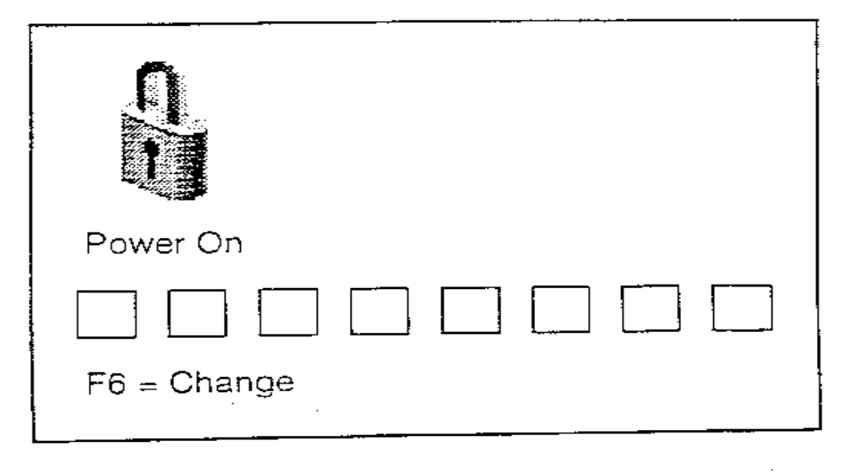
- Power-on and supervisory passwords can only be enabled or disabled through the Utilities selection provided by the System Management Services diskette.

16.22 Power-On Password - PCI RISC System/6000
Notes:
- You can use any combination of up to eight characters (A-Z, a-z, and 9-0).
- After you set a power-on password, you are prompted to enter it each time you power on the system. Before you can use the system, you must type the correct password and press the Enter key.
- When you enter the correct password, the system is unlocked and resumes normal operations. If you enter the wrong password, you are prompted to enter the correct one. After three incorrect entries, you must power off the system and start again.
- A power-on password can be set only after system power has been turned off and then on again. You cannot set a power-on password after doing a warm system startup.
- If you forget your power-on password you must remove it from memory. To do this, you must remove the battery for at least 30 seconds.

16.23 Supervisory Password - PCI RISC System/6000
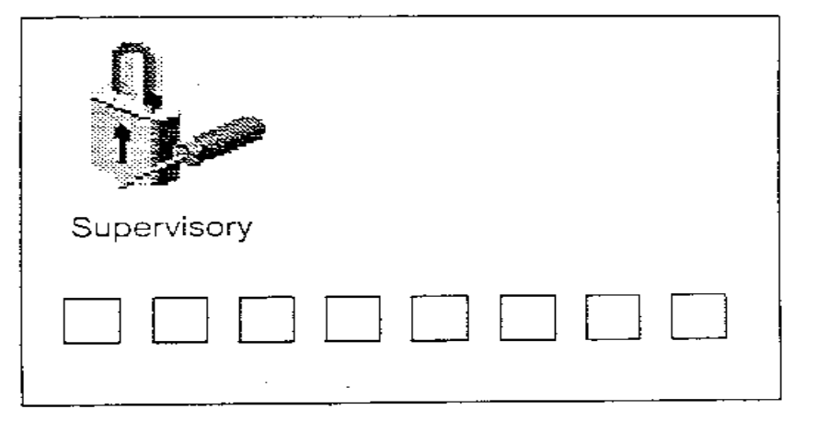Notes:
- The supervisory password protects against the unauthorized use of the System Management Services diskette. If a supervisory password is set, that password must be entered correctly before standalone mode can be invoked from the System Management Services diskette or CD-ROM.
- As with the power-on password, you must turn system power off and then on again before setting a supervisory password.
- If you forget the supervisory password, there is no way to reset it. You will have to take the covers off the system, remove the ISA/PCI riser, and remove the battery for at least 30 seconds.

16.24 Documenting Security Policy and Setup
- Identify the different types of users and what data they will need to access
- Organize groups around the type of work that is to be done
- Organize ownership of data to fit with the group structure
- Set SVTX on shared directories
- Remember that UNIX/AIX has no concept of application ownership
Notes:

16.25 Checkpoint
Exercise - Security
- What are the benefits of using the su command to switch user to root over logging in as root?
2. Why is a umask of 027 recommended?
3. Password restrictions are set in which of the following file(s)?
- /etc/passwd
- /etc/security/passwd
- /etc/security/restrictions
- /etc/security/user
4. Which of the following statements are true?
- A user can only belong to one group
- A member of the security group can administer user accounts
- An admin user is a user whose account cannot be administered by any member of the security group
- The chmod g+s command sets the SGID permission of a file
- The root user, commonly known as the superuser has UID=0 and GID=0

16.26 Unit Summary
- Every user of an AIX system must belong to at least one group, and can belong to more. If this is so, then their primary group must also be defined
- A user who is a member of a group such as security, system printq, etc. has the authority to carry out certain administrative functions on the system depending on the group that they are a member of
- The root user account should never be used for normal operations, and the account access should be closely monitored
- Apart from the base read, write and execute permissions, other permission bits such as SUID, SGID and the SVTX bits can also be set with the chmod command
- The system holds the user and group information in ASCII text files all under the /etc and /etc/security directories

